**Name : E W V Pesara**

**ID : 26708**

**SE 102.3 – Web Based Application Development**

**Tutorial**

1. Write HTML codes to create the following tables

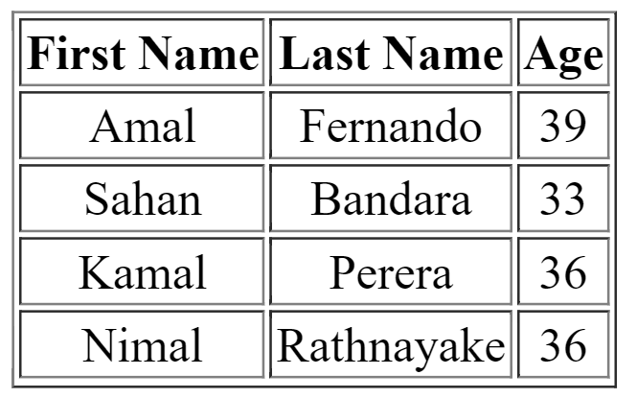

<html>

<head><title>Create Table</title>

<link href="tut.css" rel="stylesheet">

</head>

<body>

<table>

<tr>

<th>First Name</th>

<th>Last Name</th>

<th>Age</th>

</tr>

<tr>

<td>Amal</td>

<td>Fernando</td>

<td>39</td>

</tr>

<tr>

<td>Sahan </td>

<td>Bandar</td>

<td>33</td>

</tr>

<tr>

<td>Kamal</td>

<td>Perea</td>

<td>36</td>

</tr>

<tr>

<td>Nimal</td>

<td>Rathnayaka</td>

<td>36</td>

</tr>

</table>

</body>

</html>

CSS File

table{

width:400px;

}

th{

text-align:left;

}

table,th,td{

border: 1px solid black;

}

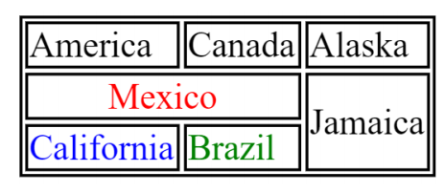

<html>

<head><title>Create Table</title>

<link href="tut.css" rel="stylesheet">

</head>

<body>

<table>

<tr>

<td>America</td>

<td>Canada</td>

<td>Alaska</td>

</tr>

<tr>

<td style= "color:red" colspan="2">Mexico</td>

<td rowspan="2">jamanica</td>

</tr>

<tr>

<td style="color:blue">Claifornia</td>

<td style="color: green">Brazil</td>

</tr>

</table>

</body>

</html>

CSS File

table{

width:400px;

}

th{

text-align:left;

}

table,th,td{

border: 1px solid black;

}

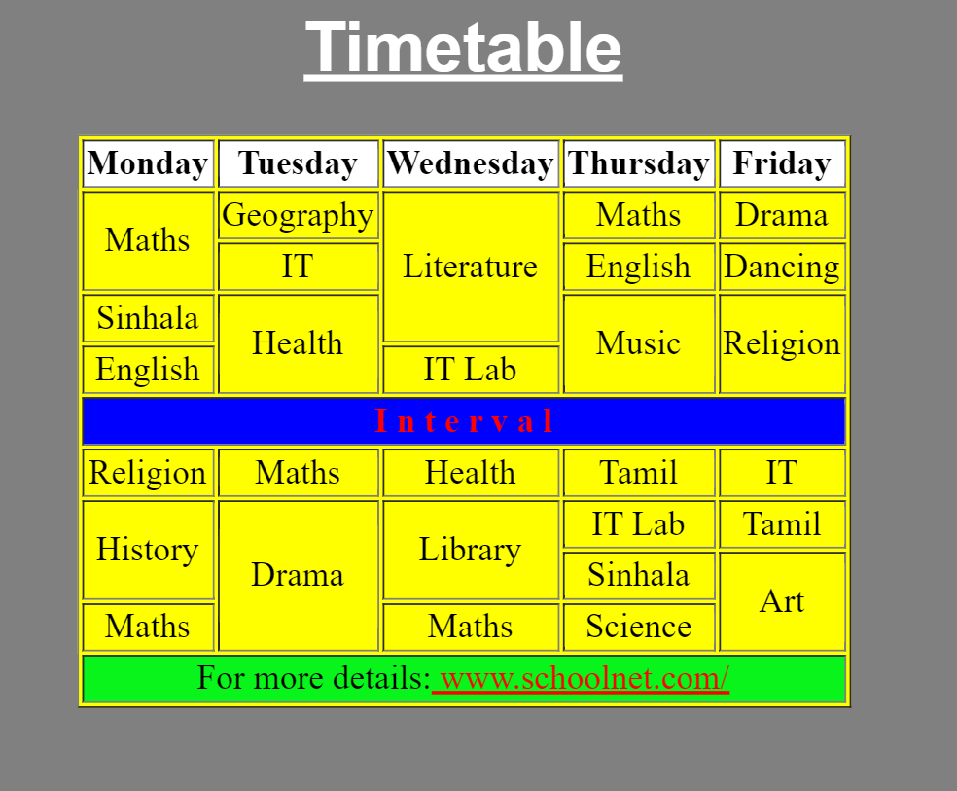

<html>

<head><title>Create Table</title>

<link href="tut.css" rel="stylesheet">

</head>

<body>

<div class="big-frame">

<table>

<caption><u>Timetable</u></caption>

<tr background="color:white">

<th>Monday</th>

<th>Tuesday</th>

<th>Wednesday</th>

<th>Thursday</th>

<th>Friday</th>

</tr>

<tr>

<td rowspan="2">Maths</td>

<td>Geography</td>

<td rowspan="3">Literature</td>

<td>Maths</td>

<td>Drama</td>

</tr>

<tr>

<td>IT</td>

<td>English</td>

<td>Dancing</td>

</tr>

<tr>

<td>sinhala</td>

<td rowspan="2">Health</td>

<td rowspan="2">Music</td>

<td rowspan="2">Religion</td>

</tr>

<tr>

<td>English</td>

<td>IT Lab</td>

</tr>

<tr>

<td style="background: blue; color: red" colspan="5" class="interval"><center>I&nbsp;n&nbsp;t&nbsp;e&nbsp;r&nbsp;v&nbsp;a&nbsp;l&nbsp;</center></td>

</tr>

<tr>

<td>Religion</td>

<td>Maths</td>

<td>Health</td>

<td>Tamil</td>

<td>IT</td>

</tr>

<tr>

<td rowspan="2">history</td>

<td rowspan="3">Drama</td>

<td rowspan="2">Library</td>

<td>IT Lab</td>

<td>Tamil</td>

</tr>

<tr>

<td>Sinhala</td>

<td rowspan="2">Art</td>

</tr>

<tr>

<td>Maths</td>

<td>Maths</td>

<td>Science</td>

</tr>

<tr>

<td colspan="5" style="background: green"><center>For more details:<a href="https://www.schoolnet.com" style="color:red"><u>www.schoolnet.com/</u></a></center></td></tr>

</table>

</div>

</body>

</html>

CSS FILE

div

{

width: 400px;

border: 2px solid grey;

padding: 40px;

margin: 0px;

background-color: grey;

}

table{

width:400px;

}

th{

text-align:left;

}

table,th,td{

border: 1px solid black;

}

table,td{

background-color: yellow;

}

table,th{

background-color: white;

}

caption{

color: white;

}